Stage 2 Requirements

IV) Design Patterns

The design pattern we have implemented is the Builder Pattern. It is a Gang of Four design pattern that is used to create complex objects with constituent parts that must be created using a specific algorithm. An external class, the director, controls the algorithm.

Example of UML Diagram:

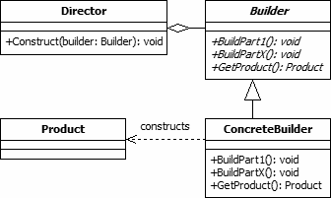

The builder class defines all of the steps that must be taken to correctly create a product. The director class controls the algorithm that generates the final product object. It calls the methods of the concrete builder in the specific order necessary to generate the desire product object.

Our implementation of the builder pattern uses a Row Builder to identify the attributes relevant to the requested type of file. An Attribute Receiver then returns the values associated with each element.